Laborator 3. IS

Atayeva Bahar.

EX:5(a)

1.Nume: Imprumut Carte

2.Scurta Descriere: Imprumut o Carte catre un client al bibliotecii.

3.Preconditii:Clientul trebuie sa fie membru al bibliotecii (auth).

4.Postconditii: Cartea sa fie valabila, Limita sa nu depasita de client. Clientul a ales un tip de imprumut.

5. Situatii de eroare: Cartea nu este valabila, limita a fost depasita, nu s-a ales tipul de imprumut.

6. starea sistemului in caz de eroare: Clientul nu ii este imprumuta nicio carte.

7. Actori: Client

8. Declasator: Clientul imprumuta o carte.

9. Proces Standart:

1) Autentificare.

2) Cerere imprumut carte (termen lung).

3) Verificare valabilitate carte

4) Verificare depasire limita.

5) Confirma Imprumut carte.

10. Procesul alternativ:

1'. Autentificare esuate.

3'. Cartea nu este valabila

4'. Limita imprumut

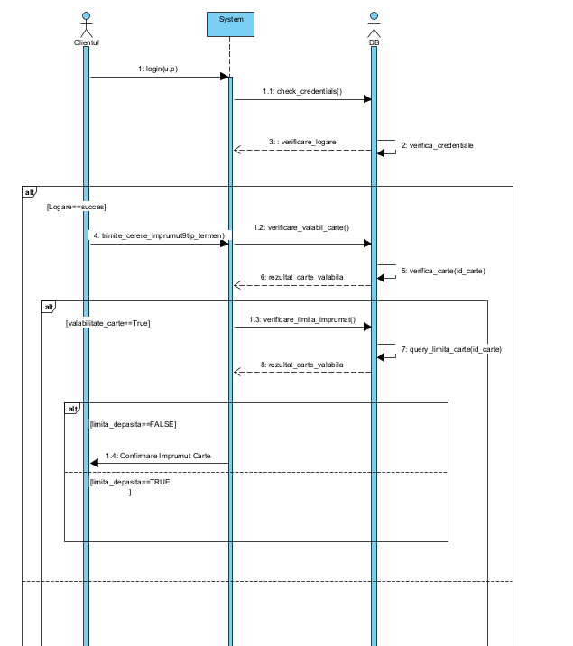

Ex.5.(b)

1. Name: Loan Extension

2. Short Description: Extends the loan of a book that has already been borrowed by a client

3. Preconditions: The client must be a member of the library.

4.Postconditions: The book must already be borrowed by the client

5. Error scenarios: Attempting to extend the loan of a book that the client has not borrowed

6. System State: The client is not allowed to extends the book loan.

7. Actors: Client

8. Triggers: The client extends the loan of a book.

Standard Process:

1. Authentication

2. Request for loan extension (Long-term)

3. Loan verification

4. Confirm loan extension

Alternative Process:

1’ Authentication failed

2’ The client is not allowed to extend the loan

